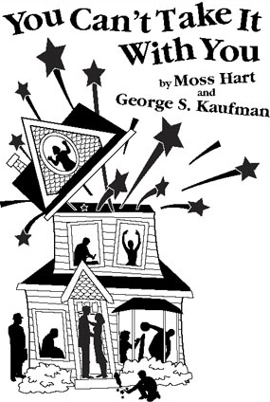
Name: ____________________

- Describe the setting. ____________________________________________________________________________________________________________________________________________________________________________________________________

- Describe three of the characters you like the best. Include what makes each one unique.
1_______________________________________________________________________________________________________________________________________________________________________________________________________________________
2_______________________________________________________________________________________________________________________________________________
________________________________________________________________________3_______________________________________________________________________
________________________________________________________________________________________________________________________________________________

- Summarize the play’s main plot.
________________________________________________________________________________________________________________________________________________
________________________________________________________________________________________________________________________________________________
________________________________________________________________________________________________________________________________________________
________________________________________________________________________________________________________________________________________________
________________________________________________________________________________________________________________________________________________
________________________________________________________________________________________________________________________________________________
________________________________________________________________________________________________________________________________________________
________________________________________________________________________________________________________________________________________________

- What is the climax of the play?
________________________________________________________________________________________________________________________________________________
________________________________________________________________________________________________________________________________________________

- How is the conflict resolved?
________________________________________________________________________________________________________________________________________________
________________________________________________________________________________________________________________________________________________
________________________________________________________________________________________________________________________________________________

- What did you think of the play?
________________________________________________________________________________________________________________________________________________
________________________________________________________________________________________________________________________________________________
________________________________________________________________________________________________________________________________________________
________________________________________________________________________________________________________________________________________________
________________________________________________________________________________________________________________________________________________

7. Which scene do you think would be the most difficult to stage? Explain why.
________________________________________________________________________________________________________________________________________________
________________________________________________________________________________________________________________________________________________
________________________________________________________________________________________________________________________________________________

8. If you were in this play, which character would you be and why?
________________________________________________________________________________________________________________________________________________
________________________________________________________________________________________________________________________________________________
________________________________________________________________________________________________________________________________________________

